**UX DESIGN 5 CREATING SCENARIOS AND STORYBOARDS**

**Introduction**

**Welcome**

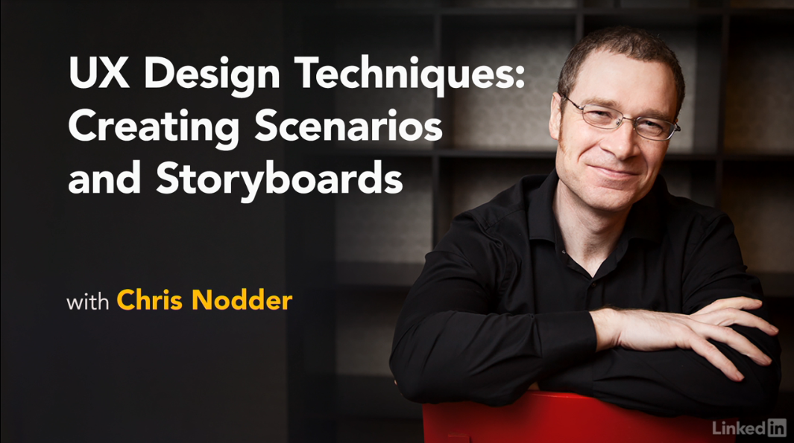

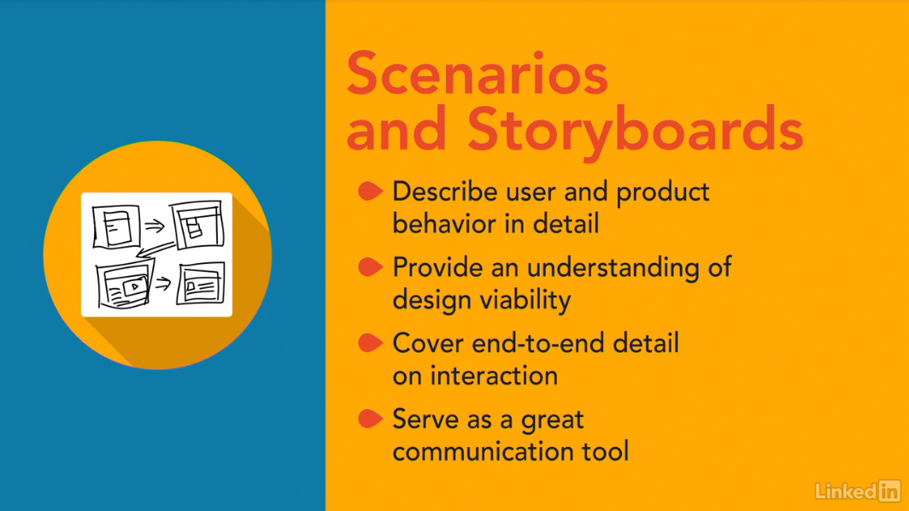

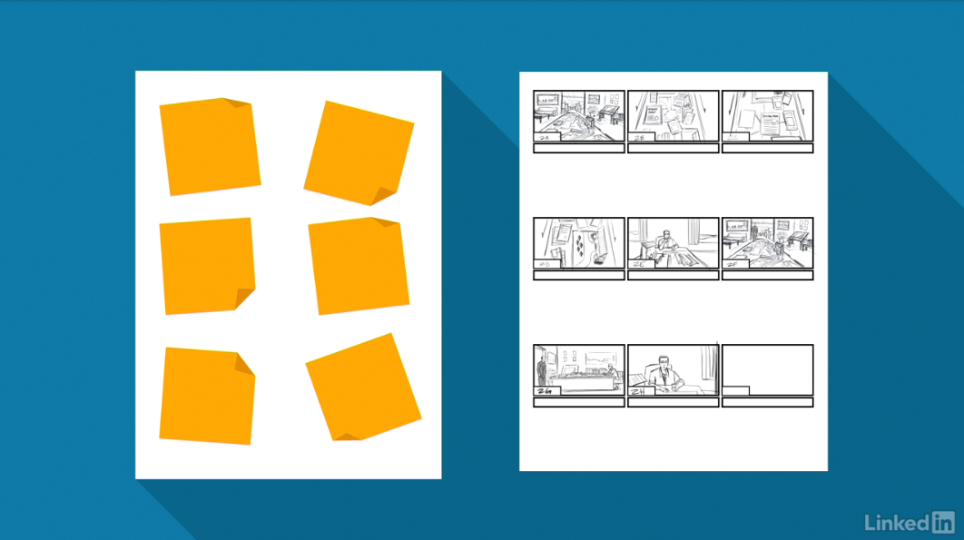

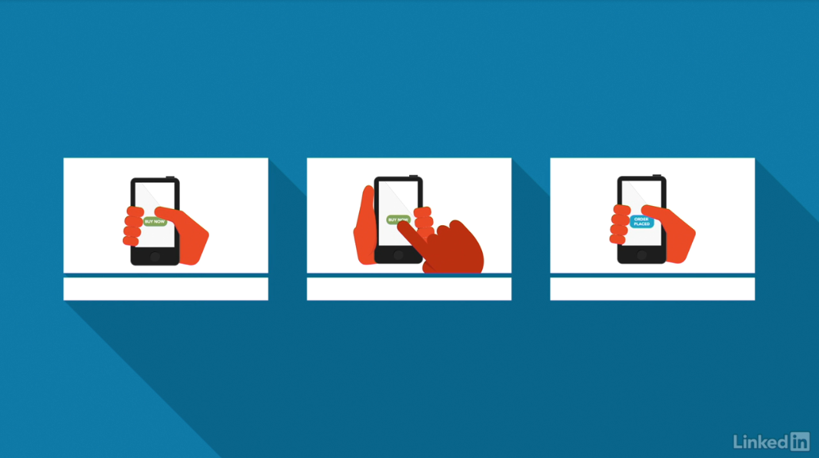

[Hello, I'm Chris Nodder, welcome to the fifth installment of the UX Design Techniques series. In this episode, we'll look at the way scenarios and storyboards help you ensure that there are no gaps in your design before you start building it. This is the fifth course in a series that describes a set of techniques you can use to make your development process more user-centered. In this course, I'll show you how to turn the ideas you generated in your ideation exercises into a more complete solution that you can subsequently prototype and build. After running design charrettes, or other similar ideation exercises, you have some great ideas for how you could design the interaction of your product to remove the pain points that users normally experience. However, at this point, you don't know how well those design ideas match with users' real-world tasks. To help flesh those designs out into full solutions, it helps to create scenarios that detail how users would interact with the feature. Then, turning those scenarios into storyboards means you can list all the areas that need to be built in order to make the solution useful and usable to your customers. It's time to take a look at the scenario and storyboard creation process. A well-thought-through storyboard helps you clearly articulate what you need to build to make users happy. So let's get started.](https://www.linkedin.com/learning/ux-design-5-creating-scenarios-and-storyboards-2/welcome?contextUrn=urn%3Ali%3AlyndaLearningPath%3A56dfbc9b92015a33b4908fdd&resume=false)

1. **Scenario and Storyboards in the User-Centered (UCD) Process**

**What are the uses of scenarios and storyboards?**

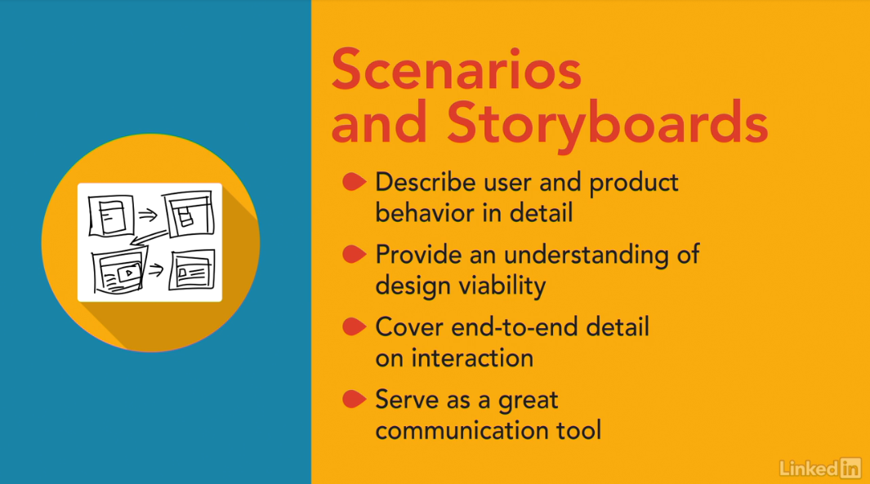

[Scenarios and story boards provide a reality check for your designs. Helping you to consider how the interaction will play out in a real environment. Once you've used ideation techniques to create some concepts for how you might want your new interface to behave, it's time to create a story that incorporates that behavior, there are a couple of reasons to do this, one is that it lets you describe the behavior in more detail to other people. The other reason is that by walking through a user's typical interactions with the interface you'll end up with a deeper understanding of how well your design idea would work in reality if you rush straight from ideation into building a solution, you're likely to miss out on some important nuances that always shows in an interface when parts of it look like they were tucked on later. The truth is, they probably were tucked on, because the developers didn't take the time to consider their user's end to end interaction with the feature, that means they had to go back and add things or change the interface in an attempt to make it feel better. Instead, scenarios and storyboards ensure that you can tell a good story about how your proposed idea helps your personas to complete their task, and how it removes their pain points and meets your goals. Scenarios and story boards help you get closer to a true design solution, and they provide a great communication tool for keeping the whole team on track as you start development work.](https://www.linkedin.com/learning/ux-design-5-creating-scenarios-and-storyboards-2/what-are-the-uses-of-scenarios-and-storyboards?autoSkip=true&contextUrn=urn%3Ali%3AlyndaLearningPath%3A56dfbc9b92015a33b4908fdd&resume=false)

**Where these techniques fit in the UCD process**

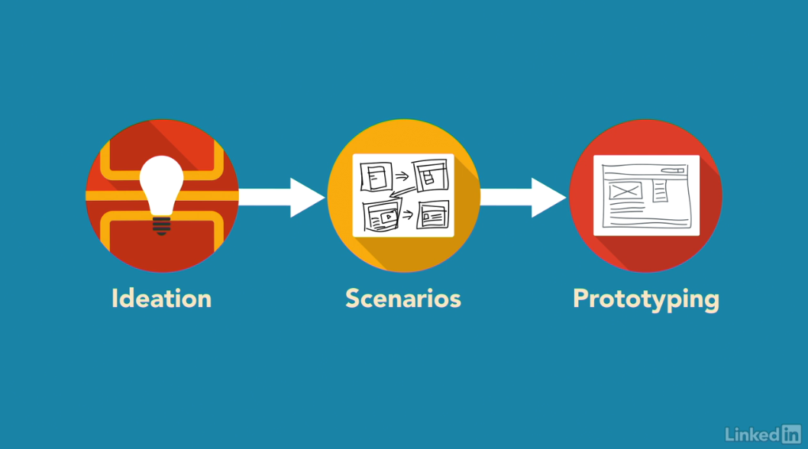

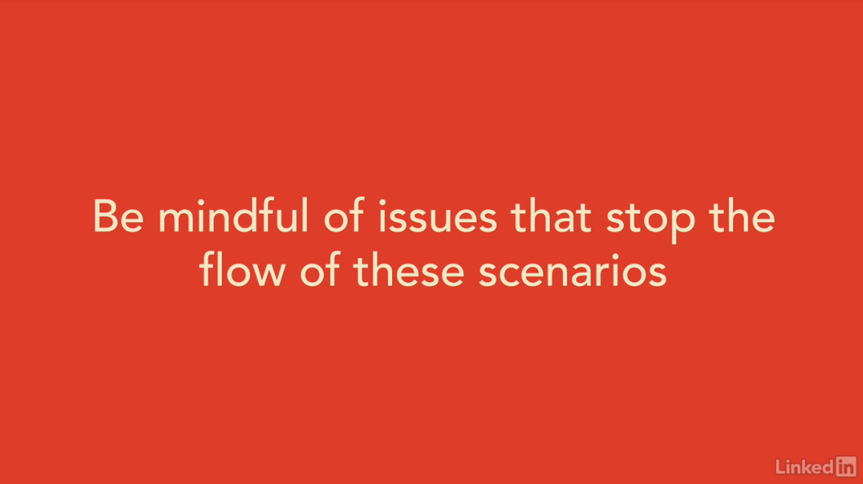

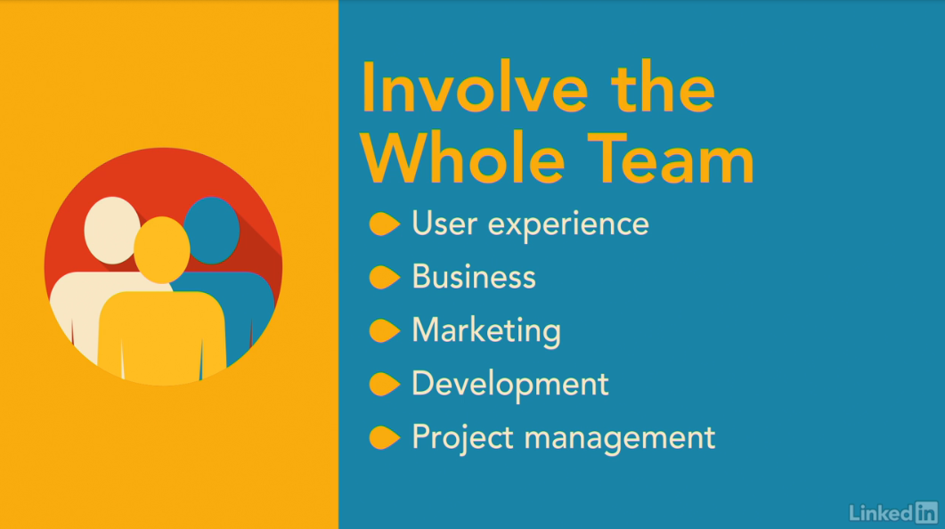

[Scenario and storyboard creation is most useful right after the ideation phase. To briefly recap, first you observe users, and then you create an experience map to extract pain points, goals, and personas. This gives you the information you need to conduct ideation exercises, such as design charrettes. Design charrettes give you a set of potential design concepts to work from. But to insure that the design charrette ideas will work in reality, you'll first create written scenarios, and then draw these out using storyboard techniques. Creating scenarios and storyboards gives us a head start on building a prototype that truly meets users' needs. Of course, the scenarios are written from the perspective of the personas you've created, so that you describe the task and your design solution in a way that would satisfy your personas' needs. The information contained in the storyboards maps almost directly to the elements that you'll need to create in order to build a suitable prototype. You might be wondering why I suggest taking this extra step between ideation and prototyping. What I've found is the creativity you use during the ideation phase needs to be tempered with reality before turning it into an interface. The process of describing how users would work with your designs allows you to explore many elements of that interaction, be mindful of issues, and develop coping strategies before you've started building the interface itself. That way, your final interface will flow smoothly through the interaction, rather than feeling like it wasn't designed for the users' full tasks. Scenario creation is the time when all the different disciplines' goals come together. There has to be a good user experience, the potential for a return on investment, a clear marketing value proposition, and the ability to deliver in a suitable time scale. The different team members involved in creating scenarios will bring the motivation from their various backgrounds to the session, and so we'll end up incorporating those elements into the scenarios you build. That means your scenarios will be believable, and everyone on the team can get behind them. Having this level of agreement between team members so early in the process means there will be less chance of hold-ups in subsequent stages of the development cycle.](https://www.linkedin.com/learning/ux-design-5-creating-scenarios-and-storyboards-2/where-these-techniques-fit-in-the-ucd-process?autoSkip=true&contextUrn=urn%3Ali%3AlyndaLearningPath%3A56dfbc9b92015a33b4908fdd&resume=false)